Theory:
Feature classification is an important step in understanding the structure of a dataset. It involves categorizing variables into numerical, categorical, ordinal, and identifier types. Numerical features can be continuous or discrete depending on their nature. Categorical features represent labels or categories and may be nominal or ordinal. Identifiers are unique columns used to distinguish records. Proper classification helps in selecting appropriate preprocessing techniques. It also assists in choosing suitable machine learning models. Understanding feature types improves data interpretation. It ensures efficient handling of each column. This step is crucial before performing any analysis.
Dataset Description:
The dataset includes columns such as Date, Open, High, Low, Close, Adj Close, and Volume. The Date column acts as an identifier. Price-related columns are numerical continuous variables. Volume represents trading activity and is numerical

Program Code:
# Step 1: Import Libraries
import pandas as pd
import numpy as np

# Step 3: Load Dataset
# Replace filename if needed
df = pd.read_csv('silver_prices_data.csv')

# Step 4: Basic Overview
print("\n===== DATASET HEAD =====")
print(df.head())

print("\n===== DATASET INFO =====")
print(df.info())

print("\n===== DATASET SHAPE =====")
print(df.shape)

# Step 5: Feature Classification Function
def classify_column(col):
if df[col].dtype == 'object':
return "Categorical (Nominal)"
elif np.issubdtype(df[col].dtype, np.integer):
unique_vals = df[col].nunique()
if unique_vals < 20:
return "Categorical (Ordinal/Discrete)"
else:
return "Numerical (Discrete)"
elif np.issubdtype(df[col].dtype, np.floating):
return "Numerical (Continuous)"
elif 'date' in col.lower():
return "Date/Time"
else:
return "Unknown"

# Step 6: Create Feature Classification Table
feature_summary = []

for col in df.columns:
feature_type = classify_column(col)
example_value = df[col].dropna().iloc[0]

feature_summary.append({
"Column Name": col,
"Data Type": str(df[col].dtype),
"Feature Type": feature_type,
"Example Value": example_value
})

feature_df = pd.DataFrame(feature_summary)

print("\n===== FEATURE CLASSIFICATION =====")
print(feature_df)

# Step 7: Add Meaning of Columns (Manually based on Silver Dataset)
column_meaning = {
"Date": "Trading date",
"Open": "Opening price of silver",
"High": "Highest price of the day",
"Low": "Lowest price of the day",
"Close": "Closing price of the day",
"Adj Close": "Adjusted closing price",
"Volume": "Number of shares traded"
}

feature_df["Meaning"] = feature_df["Column Name"].map(column_meaning)

print("\n===== FEATURE DETAILS WITH MEANING =====")
print(feature_df)

# Step 8: Identify Target Variable
target_variable = "Close" # You can change if needed

print("\n===== TARGET VARIABLE =====")
print("Target Variable:", target_variable)

# Step 9: Class Distribution
print("\n===== CLASS DISTRIBUTION =====")

if df[target_variable].dtype == 'object':
print(df[target_variable].value_counts())
else:
print(df[target_variable].describe())

# Step 10: Save Output (Optional)
feature_df.to_csv("feature_classification_output.csv", index=False)
print("\nFile saved as 'feature_classification_output.csv'")

Stepwise output:
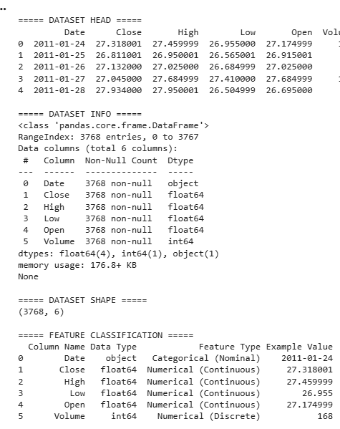
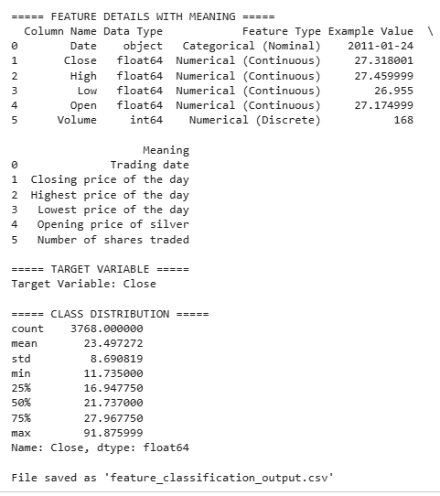

Conclusion:
The dataset mainly consists of numerical features. The Date column serves as a unique identifier. Feature classification helps in selecting appropriate preprocessing steps. It confirms the dataset is suitable for regression analytical tasks.

